

A Project Report On

**Placement Management System**

**By**

**Bachu Ravali**

**(B.Tech(Ece))**

**Batch:** 2022 – 6258

**Center: Hyderabad**

Under the Guidance of,

**Anjana Sarode**

**Technical Trainer**

**EduBridge**

(School of coding)

**Introduction:**

Our project explains about the Placement Management System. This project mainly explains the various actions related to Placement, student login, admin login. You can search various products and shuffle according to category. Our Project Include

**Modules:-**

* Admin Module
* Student Module
* Placement Module

I have developed this Application in **Java, JSP, Servlets, Hibernate and MySQL.** It’s a web-based projects so I have used **HTML, CSS, JavaScript and Bootstrap also**.

The Main Aim of this project is about to add the student details in the student form and placement details in the placement form .

If Any Student Want to add any data in the form First particular student has to create their username and password on sql form with that login details he/she has to login using the same details, and he/she can add more details or delete or edit the details in their web page form.

**Software Requirements:**

**Front end:** Java/J2EE technologies (Servlet, JSP), HTML, CSS, JavaScript, Bootstrap, Hibernate.

**Back end**: MySQL workbench 8.0.23CE.

**Middleware/Server:** Apache Tomcat v8.5. IDE: Eclipse IDE for Java EE Developers

**Browser:** Best result on Google Chrome

**Operating System:** Window 10

# Data Dictionary:

create database Placement;

USE Placement;

create table login(id bigint primary key auto_increment,username varchar(255),password varchar(255));

drop table login;

insert into login(id,username,password)values(1,"Ravali","Ravali@1499");

select * from login;

create table College(id bigint primary key auto_increment,collegename varchar(255),collegelocation varchar(255),collegeadmin varchar(255),collegeemail varchar(255));

select * from College;

create table Placement(id bigint primary key auto_increment,name varchar(255),college varchar(255),date varchar(255),qualification varchar(255),year varchar(255));

drop table Placement;

select * from Placement;

create table Student(id bigint primary key auto_increment,studentname varchar(255),course varchar(255),percentage numeric,mailid varchar(255),college varchar(255),roll bigint,qualification varchar(255),hallticketno numeric);

select * from Student;

create table student_login(id bigint primary key auto_increment,username varchar(255),password varchar(255));

drop table StudentLogin;

insert into student_login(id,username,password)values(1,"Ravali","Ravali@1499");

select * from student_login;

**Outputs**

**Admin data:**

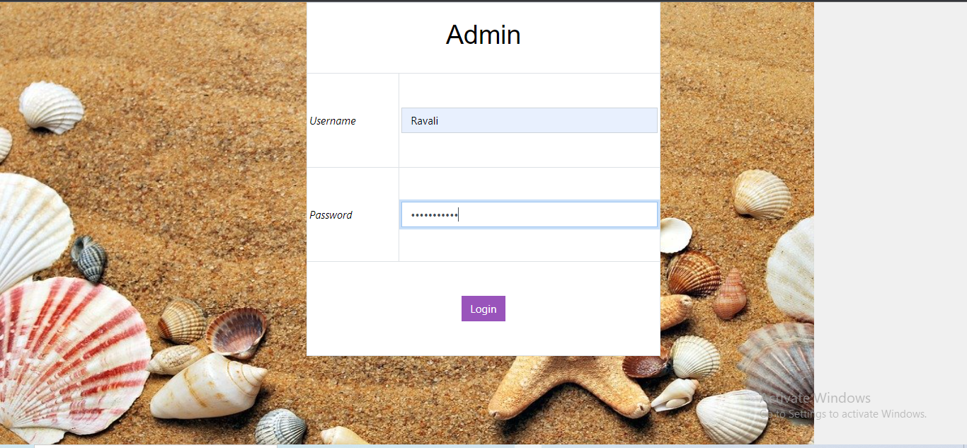

**Welcome Page:**



**Placement Details:**

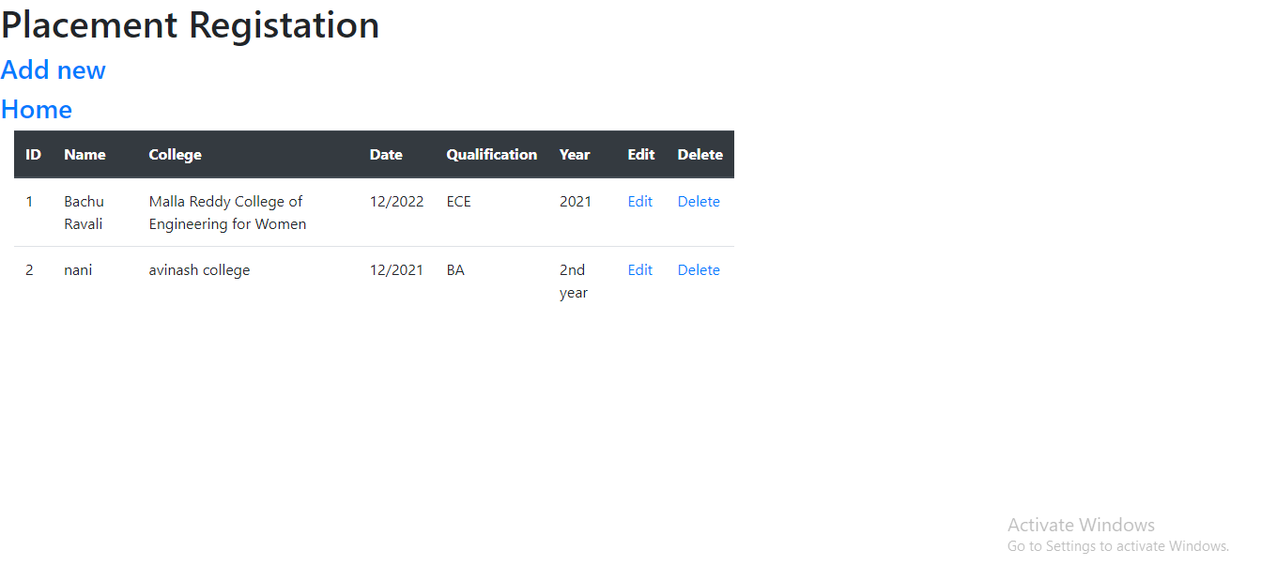

**Placement Data :**

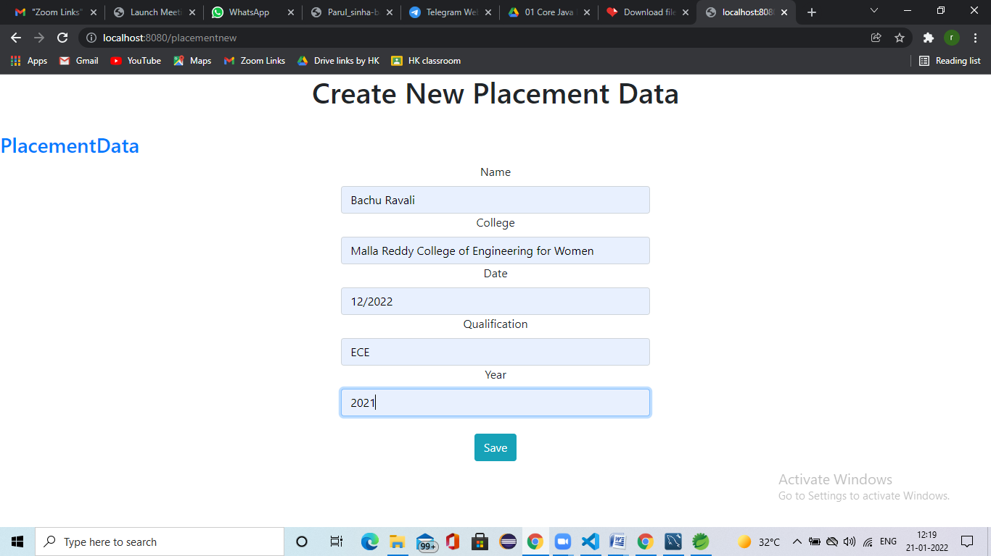

**College Details:**

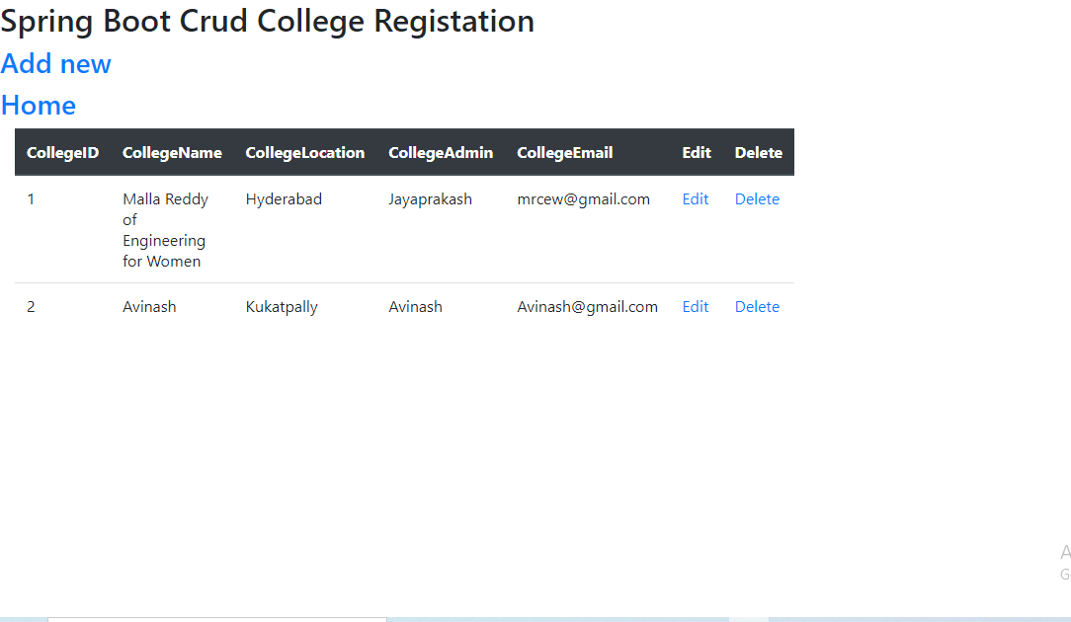

**College Details Form:**

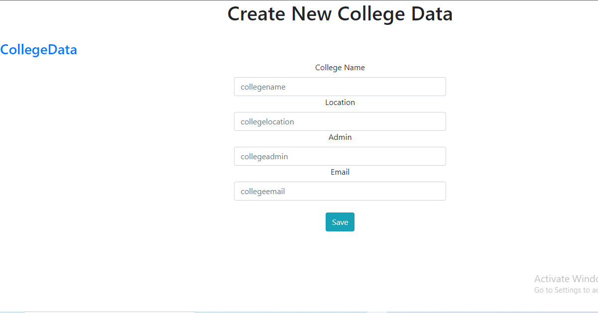

**Student Details:**

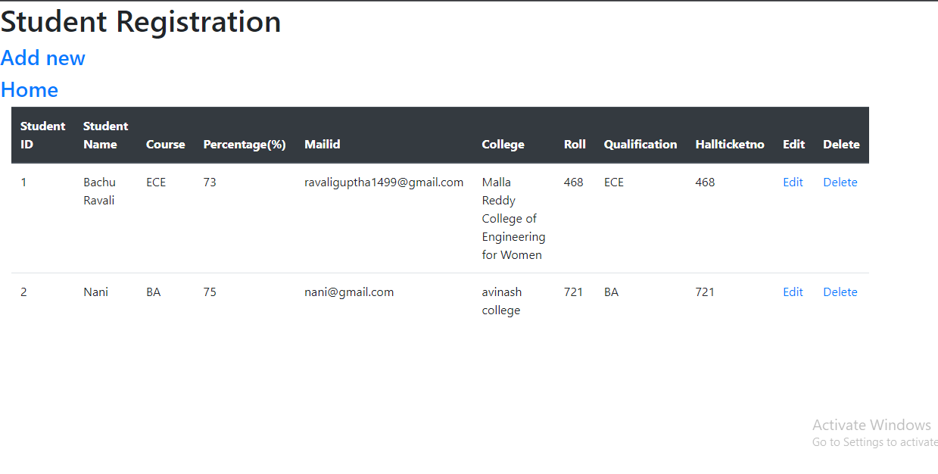

**Student Registration Form:**

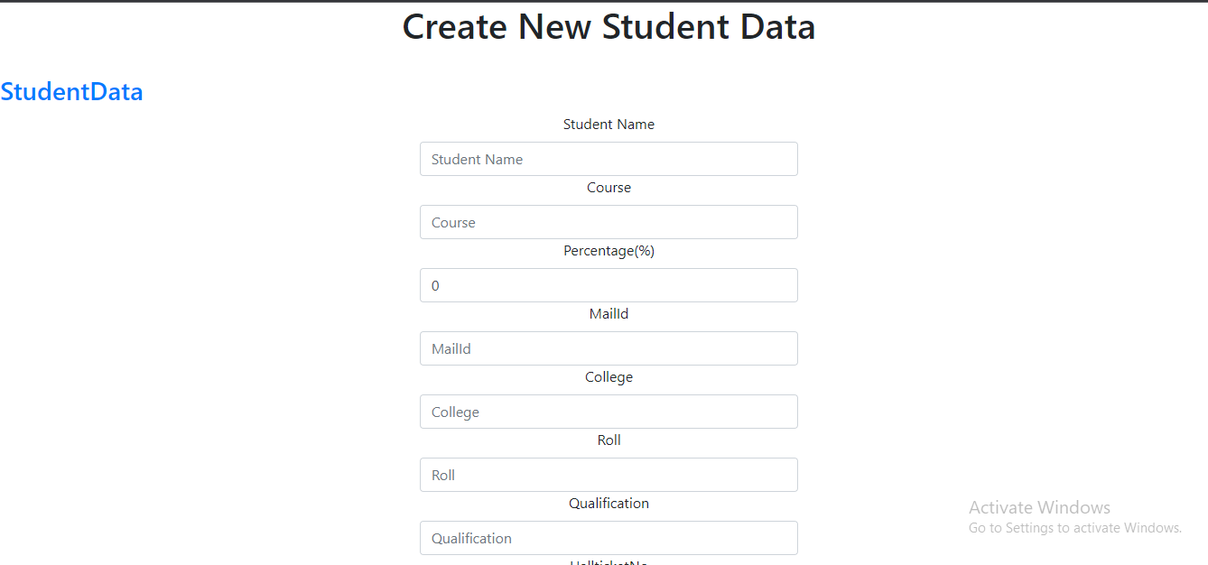

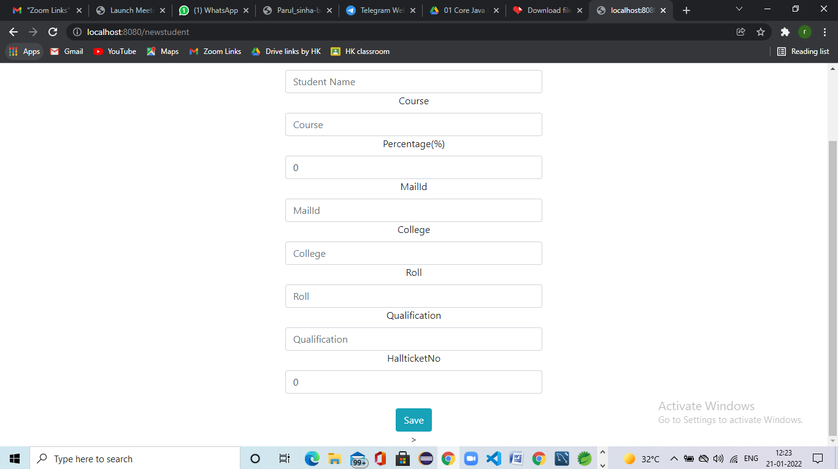

**Welcome Page For Student:**



**Admin Data:**



**Student Portal Placement Management:**

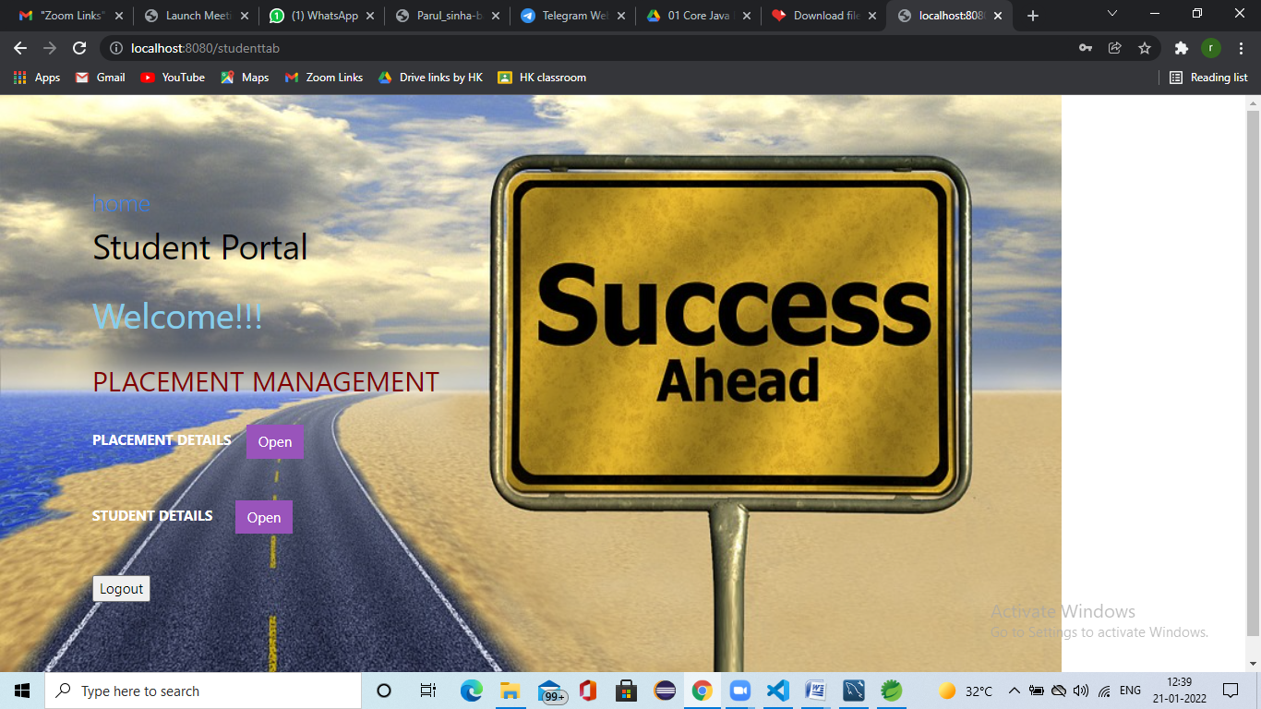

**Placement Details:**

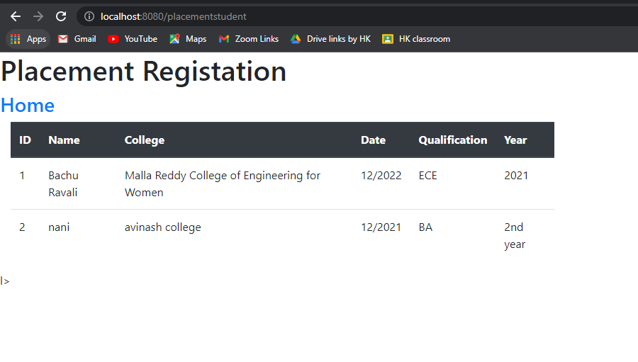

**Student Details:**

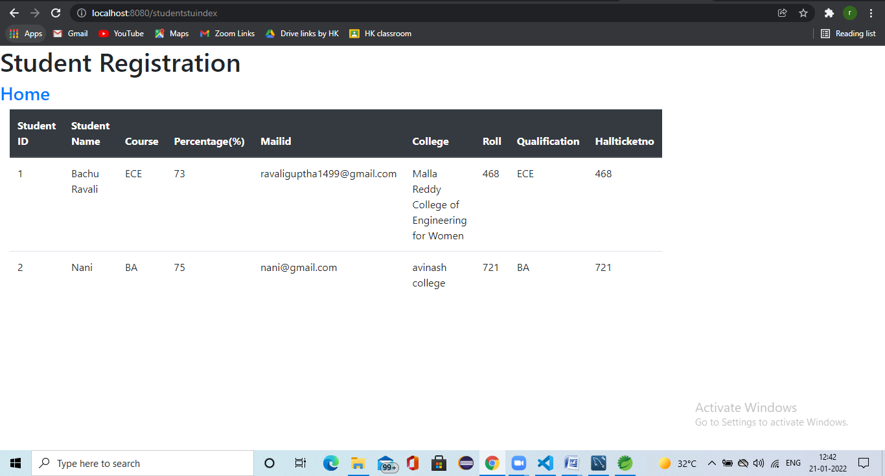

**SQL OUTPUTS**



